1/3 INCH COLOR INDOOR IR DOME CAMERA, 24PCS IR LED

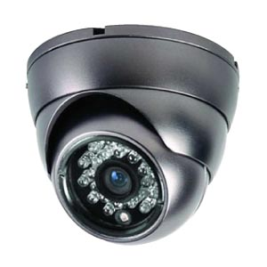

S P E C I F I C A T I O N S

1/3 INCH COLOR INDOO IR DOME CAMERA, WITH 24PCS IR LED

MODEL NO.: C3833-56BBR1 (NTSC) / C3834-56BBR1 (PAL)

PICK-UP SIZE: 1/3 INCH SONY CCD IMAGE SENSOR
SIGNAL MODE: NTSC PAL
VERTICAL FREQUENCY: 59.94 Hz 50 Hz
PICTURE ELEMENTS: 510 x 492 (NTSC) 500 x 582 (PAL)
HORIZONTAL FREQUENCY: 15.734 KHz 15.625 KHz
SYNC. MODE: INTERNAL
SCANNING SYSTEM: INTERLACE 2:1
MINIMUM ILLUMINATION: 0.02 LUX, F=1.2 (DAY), 0 LUX (IR ON)
HORIZONTAL RESOLUTION: 420 TV LINES
AUTO SHUTTER FUNCTION: AUTO
S/N RATIO: MORE THAN 48dB
GAMMA CHARACTERISTIC: r = 0.45
SYNCHRONOUS SYSTEM: INTERNAL
GAIN CONTROL: AUTO
AUTO WHITE BALANCE: AUTO
BACK LIGHT COMPENSATION: ON / OFF
AUTO ELECTRONIC SHUTTER: NTSC: 1/60s to 1/100,000s, PAL: 1/50s TO 1/110,000s
VIDEO OUTPUT: COMPOSITE 1.0 Vp-p AT 75 OHMS
TRI-AXIS MOUNT: 3-AXIS MECHANISM FOR FREE LENS ROTATION
IR LED: 24 IR LED
WAVE LENGTH: 850 nm
BEAM SPREAD: 35°
PROJECTION DISTANCE: 20 M
POWER REQUIREMENT: DC12V ± 10%
POWER CONSUMPTION: IR ON: 310mA (MAX.), IR OFF: 80mA (MAX.)
LENS FURNISHED: BUILT-IN f3.6mm BOARD LENS (OPTIONS: 6mm)
OPERATING TEMPERATURE: -10°C to +45°C
DIMENSIONS : 119(Φ) x 96.6(H)mm
WEIGHT : 200g

